Student’s lab report
Practical laboratories – block 3
Brain anatomy

1)Name marked structures of the brain.
1.1) lateral surface of the brain
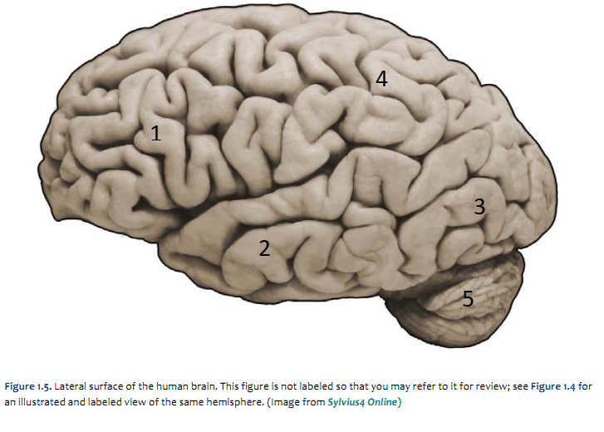
  - ventral surface of the brain
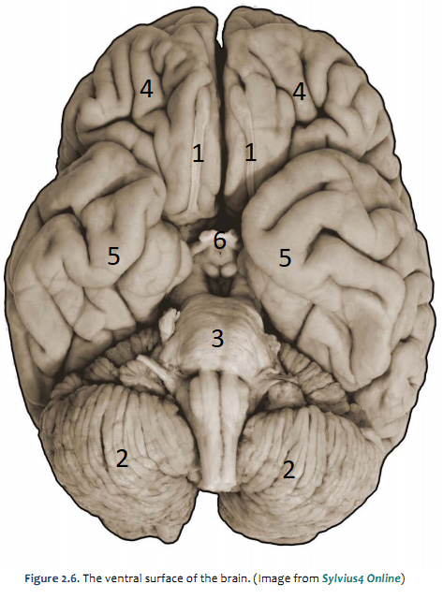
  - Midsagittal section
